**Lab-1**

1. AND GATE:

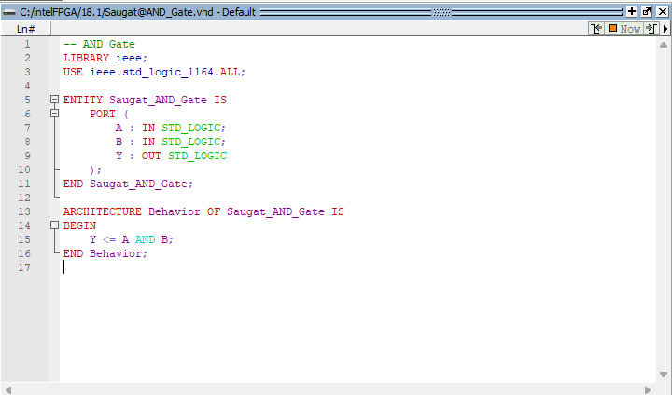

Output (Wave):

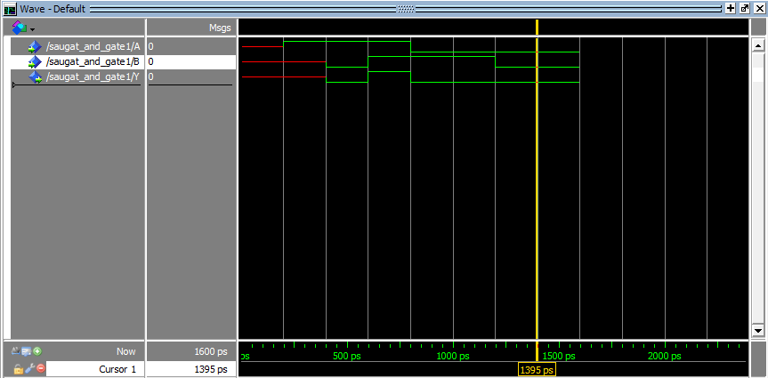

1. OR GATE:

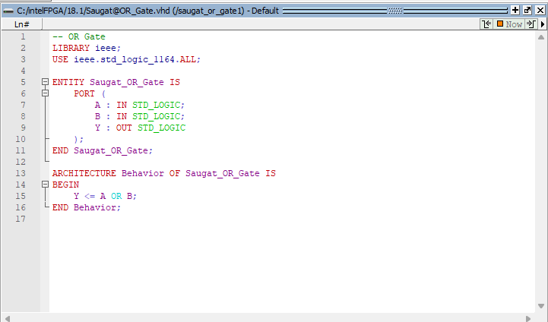

OUTPUT (Wave):

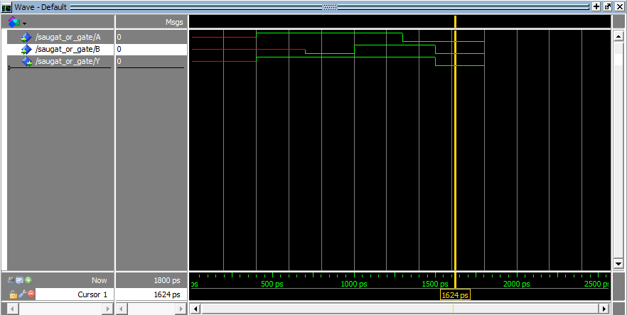

1. NOT GATE:

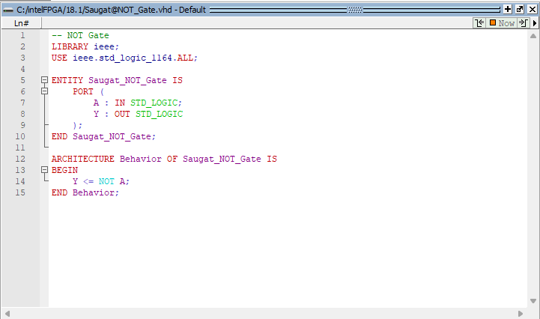

OUTPUT(Wave):

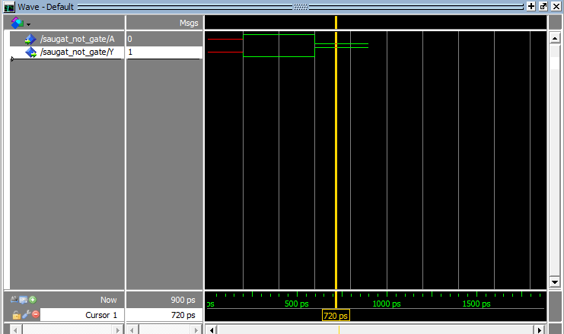

1. NOR GATE:

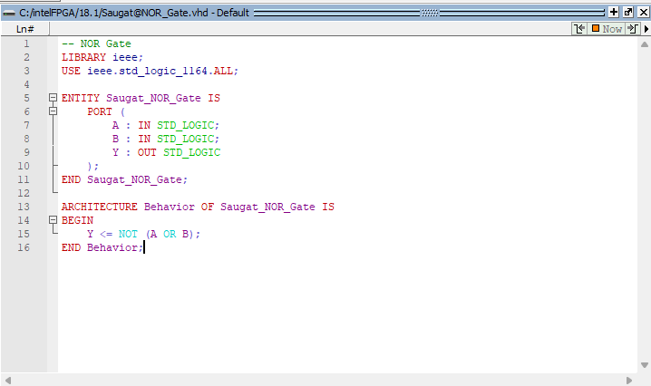

OUTPUT(Wave):

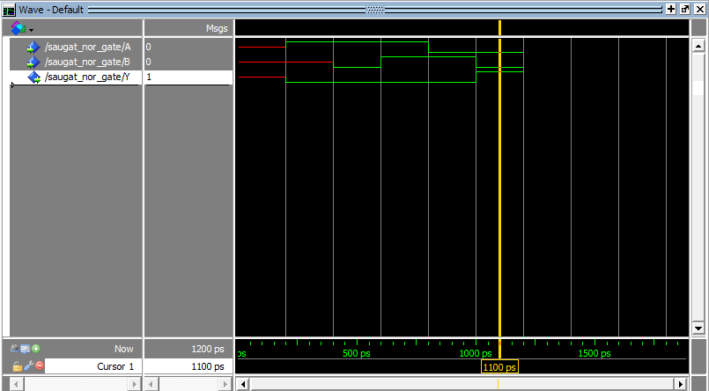

1. NAND GATE:

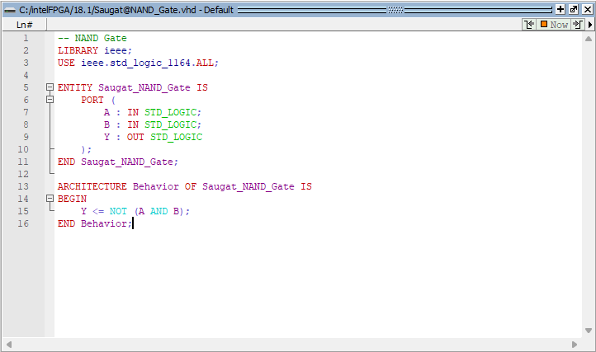

OUTPUT(Wave) :

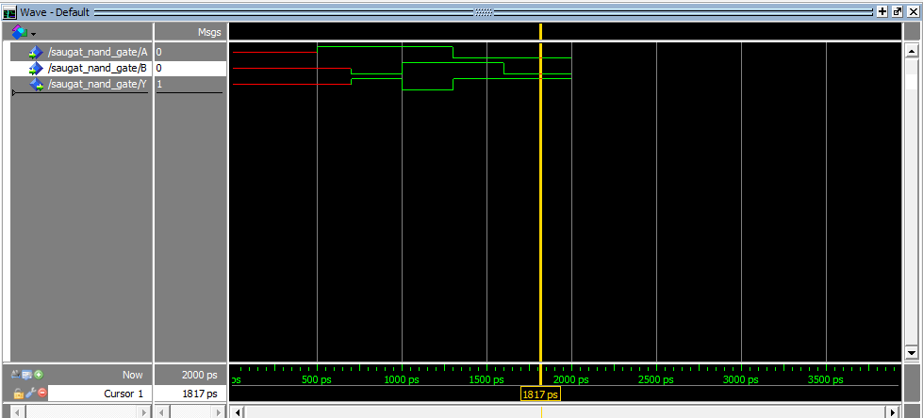

1. X-OR GATE:

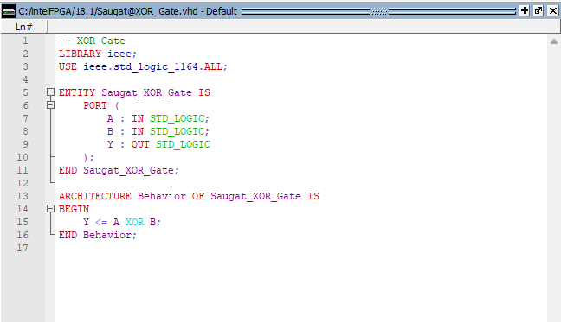

OUTPUT(Wave) :

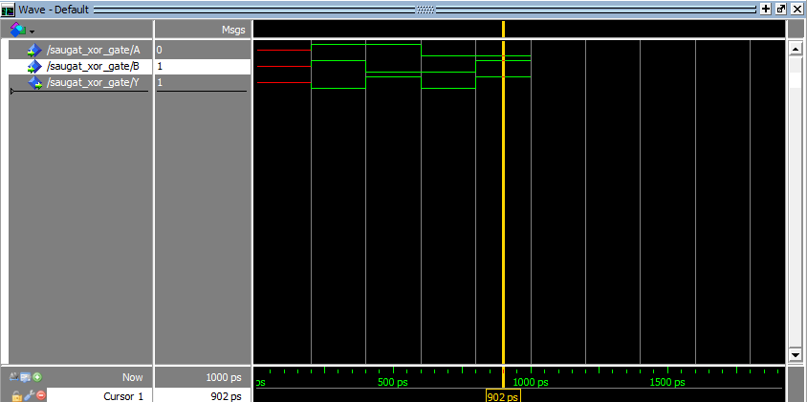

1. X-NOR GATE:

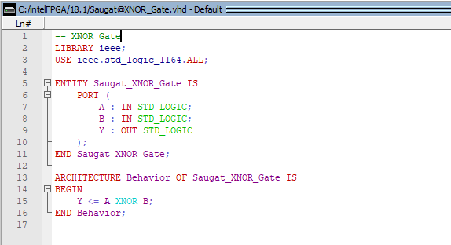

OUTPUT(Wave):

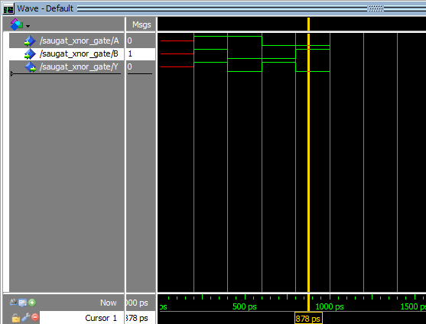

1. ALL-COMBINED GATES:

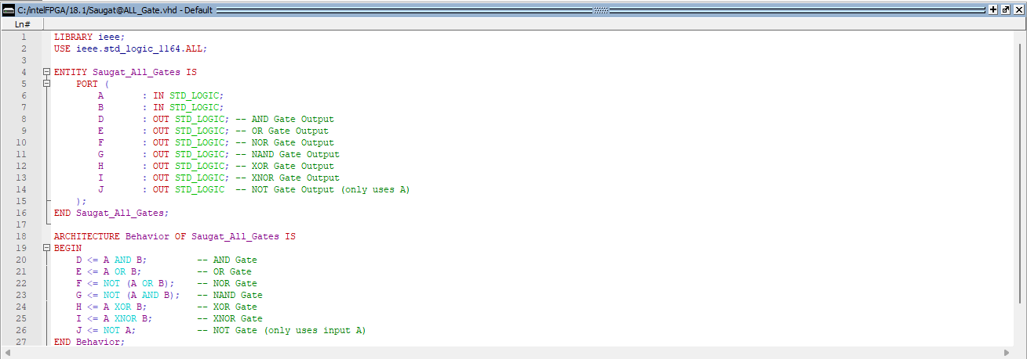

OUTPUT(Wave):

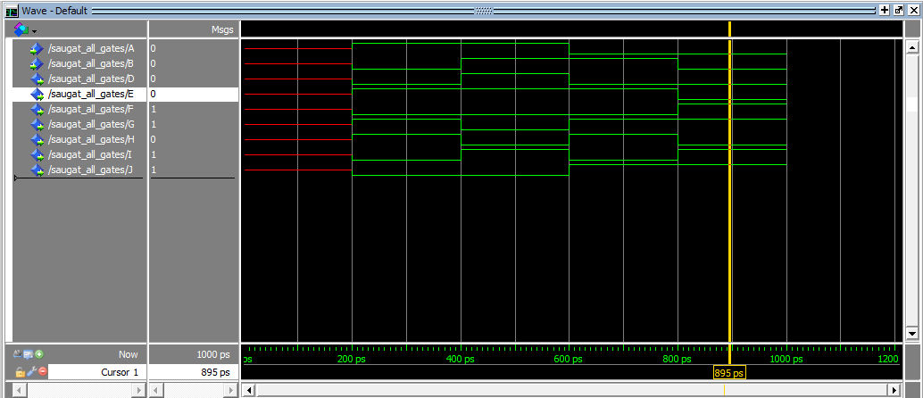

**Lab-2**

1. Half-Adder:

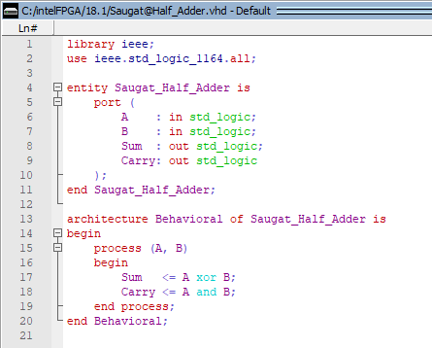

OUTPUT(Wave):

1. Half-Subractor:

OUTPUT(Wave):

**Lab-3**

1. Full-Adder:

OUTPUT(Wave):

1. Full-Subtractor:

OUTPUT(Wave):

**Lab-4**

1. Overflow:

OUTPUT(Wave):

**Lab-5**

1. Binary-Subtractor-Adder (BSA):

**Lab-6**

1. Arithmetic Logical Unit (ALU):

OUTPUT(Wave):

**Lab-7**

1. Control Unit (CU):

OUTPUT(Wave):

**Lab-8**

1. Maping:

OUTPUT(Wave):

**Lab-9**

1. Parity Generator:

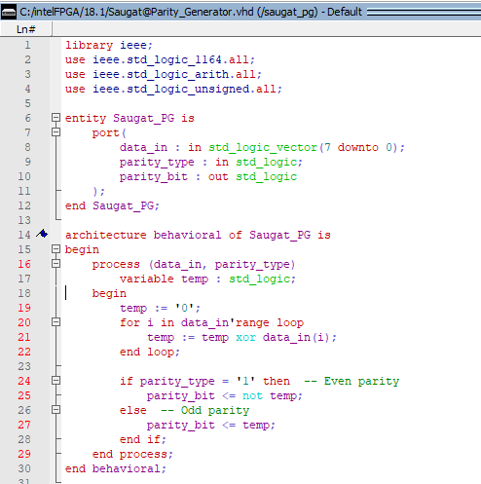

OUTPUT(Wave):

**Lab-10**

1. Parity Checker:

OUTPUT(Wave):

**Lab-11**

1. Encoder:

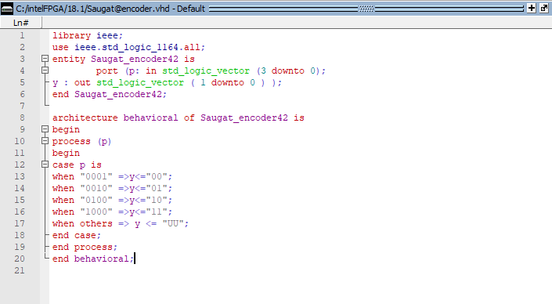

OUTPUT(Wave):

**Lab-12**

1. Decoder:

OUTPUT(Wave):

**Lab-13**

1. Multiplexer:

OUTPUT(Wave):

